Datasheet for C3A/ Cas9-hyg Stable Cell Line

Catalog number: SL543

Product: C3A cell line stably expressing CRISPR Cas9 nuclease

Description: This product is a cell line stably expressing the CRISPR Cas9 nuclease. This cell line also expresses the hygromycin resistance gene. In combination with separately transfected or transduced single guide RNAs (sgRNAs), this cell line will sustain double-strand DNA breaks (DSBs) at targeted genome sites . We found the basal Cas9 activity by T7 Endonuclease I assay when sgRNA expression at high levels using lentivirus transduction. This cell line can be used in vitro for gene knockout, transgene knockin, mutagenesis, transgene integration, or other genome editing-related applications.

Quantity: 1 vial of 2 x 106 cells; frozen

Shipping conditions: Dry ice

Storage conditions: Liquid nitrogen vapor phase. Remove the item from the dry ice packaging and check all items for damage and leakage. Place immediately into storage at or below -140 0C, preferably into the liquid nitrogen vapor phase, until use.

Transgene integration:

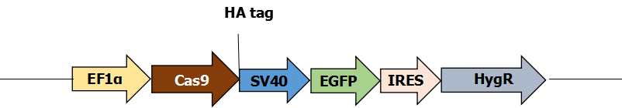
Source of parental line:

C3A
Organism: Homo sapiens, human Tissue: liver
Cell type: epithelial

Quality control: >95% viability before freezing. All cells were tested and found to be free of mycoplasma, bacteria, viruses, and other toxins.

Safety instructions: To ensure safety, protective gloves, clothing, and a face mask should be worn when handling frozen vials. Some leakage may occur into the vial during storage. The liquid nitrogen will be converted to gas upon thawing. Due to the nature of nitrogen gas, pressure may build within the vial and possibly result in the vial exploding or losing its cap. This may cause flying debris.

Thawing procedure: The vial of cells should be thawed in a 37 0C water bath with gentle agitation. For optimal performance, the vial should be thawed in under two minutes. Ensure that the cap of the vial did not loosen upon thawing, and re-tighten as needed. Spray the vial with 70% EtOH and wipe off. Repeat. Using aseptic technique, add the contents of the vial to 9 ml of complete growth medium (without selection). Centrifuge for 5 min. at 250 x g. Aspirate the medium, being careful not to disturb the pellet. Resuspend in 10 mL of complete growth medium, and place into a culture vessel of your choice. Only add selection to the medium after 24 hours in culture.

Culture conditions:

Complete Growth Medium

The base medium for this cell line is RPMI1640. For optimal growth and maintenance of selection, add the following components to the base medium: fetal bovine serum to a final concentration of 20%.

Selection

Hygromycin to a final concentration of 400 µg/mL

Culture temperature:

37 0C with 5% CO2

Subculture:

Rinse the cells with PBS without cations, digest cells with 0.25% (w/v) Trypsin-EDTA (0.53 mM) solution and split at 1:3 to 1:6 ratio.

Cryopreservation: Freeze slowly in complete growth medium supplemented with 5% (v/v) DMSO.

Mycoplasma: Negative

Product QC:

T7 Endonuclease I (T7 E1) Assay

HUWE Site T7 E1 Assay
sgRNA targeting to HUWE gene was transduced into C3A/ Cas9-hyg Stable Cell Line by transduction. HUWE gene was cut by CAS9 expressed inside the cells and repaired through NHEJ with mutation. A 525 bp HUWE gene fragment from PCR was then tested by T7 Endonuclease I (T7 E1) Assay. The T7 E1 cleavage will results in two additional bands: one ~192 bp and the other ~333 bp.

HUWE-F:AAGGGTGGGACGTGAACTTGTC
HUWE-R:AGAATCTTCCCATCAACCCT
M
PCR
T7E1

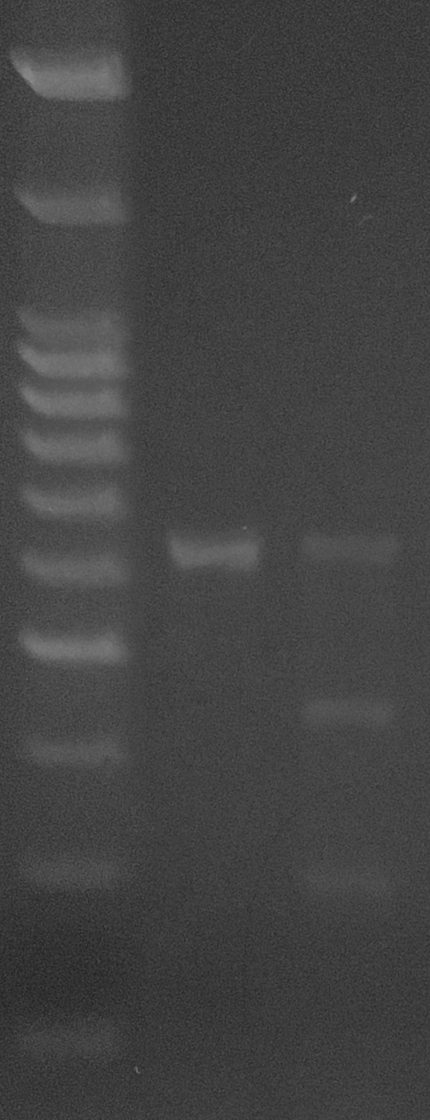
100 bp--

200 bp--

300 bp--

400 bp--

500 bp--

600 bp--

700 bp--

Citation of product: If use of this item results in a publication, please use this information: CRISPR Cas9 C3A/ Cas9-hyg Stable cell line (SL543, GeneCopoeia, Inc., Rockville, MD).

Limited Use License

A limited use license is granted to the Buyer of the Product. The Product shall be used by the Buyer for internal research purposes only. The Product is expressly not designed, intended, or warranted for use in humans or for therapeutic or diagnostic use. The Product must not be resold, repackaged or modified for resale, or used to manufacture commercial products without prior written consent from GeneCopoeia. This Product should be used in accordance with NIH guidelines developed for recombinant DNA and genetic research. Use of any part of the Product constitutes acceptance of the above terms.

Copyright ©2015 GeneCopoeia, Inc.

C9SCL-DS-063015

GeneCopoeia, Inc.
9620 Medical Center Drive, #101
Rockville, MD 20850 USA
Tel: 301-762-0888; Fax: 301-762-3888
Email: support@genecopoeia.com
Web: www.genecopoeia.com

